|  |  |  |  |  |  |  |  |
| --- | --- | --- | --- | --- | --- | --- | --- |
| **ASSIGNMENT COVERSHEET** | | | | UTS LOGO | | | |
| **UTS: ENGINEERING & INFORMATION TECHNOLOGY** | | | | | | | |
|  | **NAME OF STUDENT(s) (PRINT CLEARLY)**  Joel Cappelli  *SURNAME FIRST NAME* | | | | | | **STUDENT ID(s).**  12137384 |
| **STUDENT EMAIL**  joel.cappell@gmail.com | | | | **STUDENT CONTACT NUMBER**  0422 384 087 | | | |
| **NAME OF TUTOR** | | | **TUTORIAL GROUP** | | | **DUE DATE**  16 June 2016 | |
| **ASSESSMENT ITEM NUMBER/ TITLE**  Hung Nguyen  49275 NEURAL NETWORKS AND FUZZY LOGIC Major Project | | | | | | | |
| 🗆 I confirm that I have read, understood and followed the guidelines for assignment submission and presentation on page 2 of this cover sheet.  🗆 I confirm that I have read, understood and followed the advice in my Subject Outline about assessment requirements.  🗆 I understand that if this assignment is submitted after the due date it may incur a penalty for lateness unless I have previously had an extension of time approved and have attached the written confirmation of this extension.  **Declaration of Originality**: The work contained in this assignment, other than that specifically attributed to another source, is that of the author(s) and has not been previously submitted for assessment. I understand that, should this declaration be found to be false, disciplinary action could be taken and penalties imposed in accordance with University policy and rules. In the statement below, I have indicated the extent to which I have collaborated with others, whom I have named.  **Statement of Collaboration**:    15 June 2016  **Signature of Student(s) ____________________________________________________________**Date**_________________________** | | | | | | | |
| - -- - - - - - - - - - - - - - - - - - - - - - - - - - - - - - - - - - - - - - - - - - - - - - - - - - - - - - - - - - - - - - - - - - - - - - - - - - - - - - - - - - - - - - - - - - - - - - - - - - - - | | | | | | | |
| **ASSIGNMENT RECEIPT** | | | | To be completed by the student if a receipt is required | | | |
| **SUBJECT NAME/NUMBER** | | **NAME OF TUTOR**  49275 NEURAL NETWORKS AND FUZZY LOGIC | | | | | |
| **SIGNATURE OF TUTOR** | | | | | **RECEIVED DATE**  15 June 2016 | | |

# **49275 NEURAL NETWORKS AND FUZZY LOGIC**

## Major Project

## The use of data mining and neural networks for forecasting stock market returns

### Joel Cappelli

### 12137384 15 June 2016

## Project Overview

This project examines the performance of different one-day ahead forecasting models of the **S&P**/**ASX 200 XJO** Australian Stock Exchange Index. The **S&P**/**ASX 200 XJO** is recognised as the institutional investable benchmark in Australia. The index covers approximately 80% of Australian equity market capitalisation and measures the performance of the 200 largest index-eligible stocks listed by float-adjusted market capitalization. The index was launched in April 2000.

The forecasting techniques examined were feedforward multi-layer perceptron networks (MLP), generalised regression neural network (GRNN) and probabilistic neural network (PNN). Both prediction of the level of next-day index return (continuous target) and next-day index direction movement (classification – up/down) is considered. Performance of the models was evaluated by using classification rate, model metrics and trading simulations.

Results show that the MLP classification network was the dominant predictor of next day index movement. This was demonstrated by the highest classification rate on out-of-sample data and best performance in trading simulations. These results prove the usefulness of non-linear models such as Neural Networks for intra-day prediction.

The methodology of this project follows that of [1].

## Literature review

There have been a total of 412 articles published between 1994 and 2015 focusing on the use of Artificial Neural Networks in the field of finance [3]. Applications in shares/bonds and bankruptcy and financial distress prediction are the most prominent [4]. Many studies in stock forecasting/trading have been aimed at specially predicting the price levels of indices or stock. However, some recent studies have suggested that trading strategies guided by forecasts on the direction of price change may be more effective and may lead to higher profits [1], [2]. Forecasting period is typically one month ahead for papers authored pre-2000 and most feature New York Stock Exchange Indices (NYSE).

Most implementations of Neural Networks in this domain use feedforward multi-layer networks with gradient descent backpropagation learning techniques. Hybrid learning and self-organising architecture methods are becoming more popular as computing technology has improved and open-source implementations are readily available [3].

Extensive review of available literature has revealed there are no papers which examine intra-day returns of the **S&P**/**ASX 200 XJO** and forecast via return level/direction predictors [5].

## Project aim and approach

The project approach is as follows:

* Select relevant input variables from a variety of sources such as intermarket indices, exchange rates, interest rates and commodities.
* Build next-day Neural Network forecasting models of return level and direction of the **S&P**/**ASX 200 XJO.**
* Compare the performance of a variety of Network architectures through model metrics and trading simulations.

## System design

### Data selection

The selection of input variables is an important process of model building. An understanding of the economics of the market of interest (ASX) can help decide which factors could be important. This should also be complemented by quantitative analysis. One should also consider the frequency of output variable of interest and data availability/consistency/completeness.

Recent studies have shown that the intermarket influences enhance the prediction accuracy [5]. Major global indices such as the S&P500, Canadian Financials Sector and Shanghai Composite have been selected. Two major exchange rates have also been incorporated to capture the effect of foreign interest rate market movements such as AUD/USD (currency) and USD/JPY (Currency). While local interest rate market movements will be reflected in Government Bond yields and Bank-Bills. Due to the principal components in the yield curve, short end (< 1 year) and long term (>5 year) yields are crucial. Commodity market factors are captured using Gold and crude oil prices. Intra-day forecasts are less influenced by macro-economic factors such as GDP and CPI therefore they have not been selected.

Specifically, only observable, but not future data were employed as inputs to the forecasting models. A summary of all collected data is shown in Appendix Section 8. 16 years of daily data (4275 trading days from May 2000 to May 2016) from Bloomberg, Quandl and Reserve Bank of Australia (RBA), 60%/20%/20% training/test/validation split, 10 years for training and 6 years for out-of-sample validation and test. Log-difference $(ln(P_{t})-ln⁡(P_{t-1}))$ of variables were provided to the network so that different input variables could be compared. There variables were used to predict the level and to classify the sign of the intra-day stock return of *'ASX200_DAILY_PX’* based upon information available at trading day open.

**Level Predictor**

$${TargetReturn}_{t}=ln⁡({LastPrice}_{t})-ln⁡({OpenPrice}_{t})$$

**Classification Predictor**

$${DirectionReturn}_{t}=sign({TargetReturn}_{t})$$

### Neural Network Models

**Stock direction inference – PNN (Probabilistic NN)**

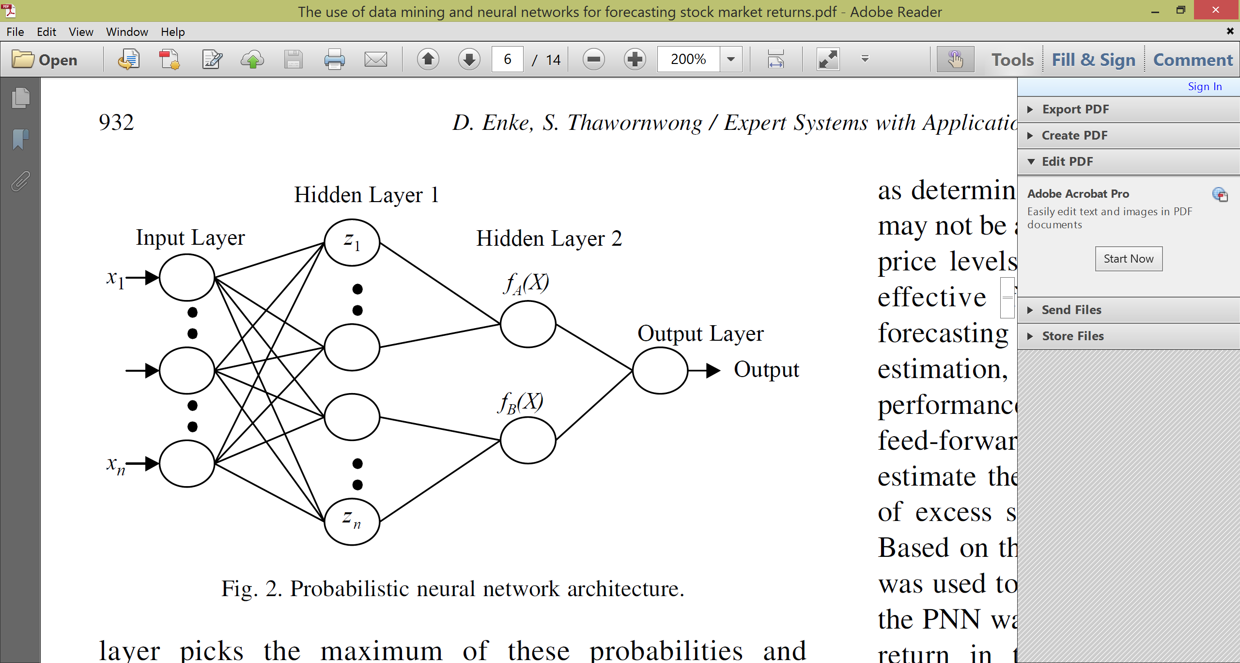

“Choose output

based on max

probability”

**Stock return forecasting – GRNN** **(Generalised regression NN)**

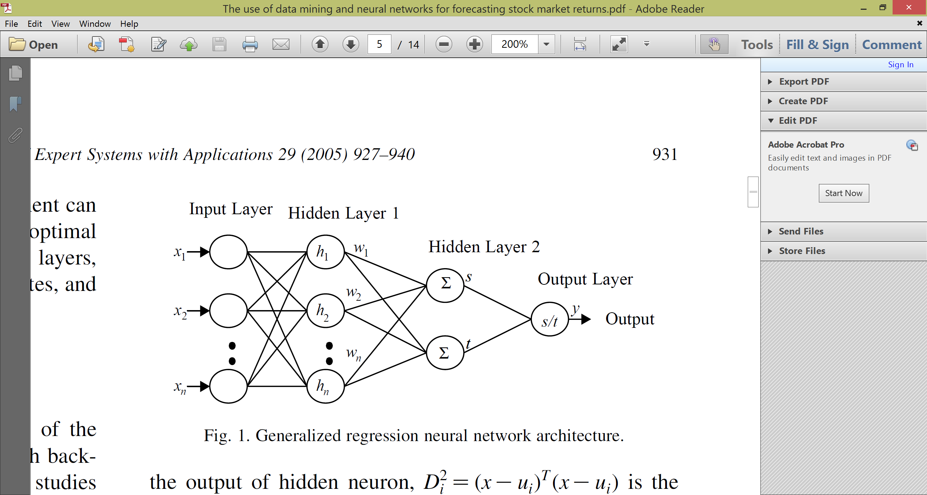

“optimal expected value of y given x”

The network contains the entire training set. Each hidden neuron is linked to a training pattern. Sigma in the radial basis function is the only free parameter that can be modified.

$${D_{i}}^{2}={(x_{i}-u_{i}))}^{T}(x_{i}-u_{i})$$

$$z_{i}=exp[-\frac{{D_{i}}^{2}}{2{σ_{i}}^{2}}]$$

“radial basis distance from every training sample”

$$f_{A}(x)= \frac{1}{(2{π)}^{P/2}σ^{P}n}\sum_{i=1}^{n}{z_{i}}$$

$f_{A}(x)$ is the probability density function estimator for class A

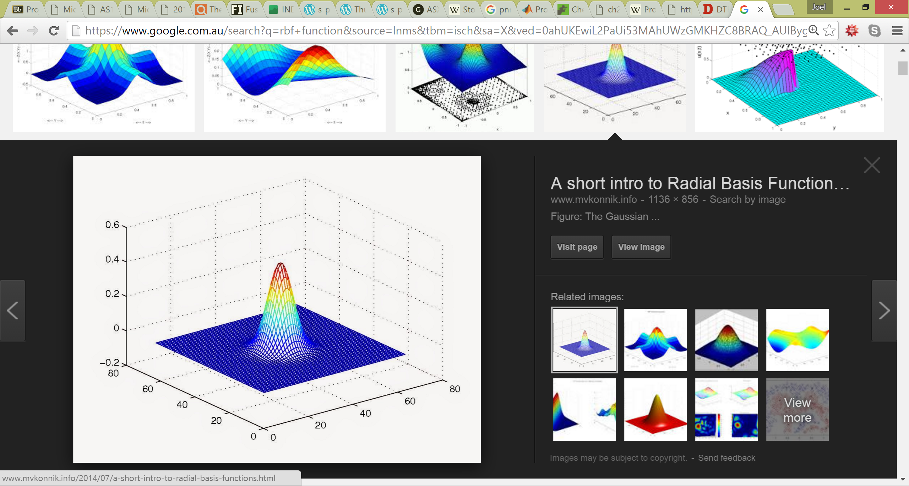

$$y= \frac{\sum_{i=1}^{n}{h_{i}w_{i}}}{\sum_{i=1}^{n}{h_{i}}}$$

$$w_{i}=ith target value$$

**Stock direction/return inference – MLP (Multi-layer perceptron)**

Describe ….

### Block diagram

**Input variables**

Global market indices

Treasury and/or government bonds

Dividend yield of ASX200

FX Rates, USD/Yen, USD/JPY, AUD/USD

Commodities

**Data mining and feature selection**

Information gain analysis

Compute log-diff of each input variable

Standardise inputs

Max-min outputs

Direction network

(+/-)

Stock return network

(x %)

Apply trading rules

**OR**

## Implementation

Correlation heat map used to isolate variables with correlation < 0.8.

Results in in Appendix Section 2, show that an ordinary-least-squares linear regression run on a subset of the data to predict the

. S&P/ASX 200 Gross Daily Dividends

* S&P 500 (U.S.)
* S&P/TSX Financials Sector Index (Canada)
* Shanghai Composite Index (China)
* Gold (Commodity)
* WTI Crude Oil (Commodity)
* AUD/USD (Currency)
* USD/JPY (Currency)
* Australian 90 Day Bank Bill
* Australian Government 10 Year Bonds
* United States 10 Year Treasury Note
* Python 2.7
* Utilises open-source libraries, such as NeuPy and scikit-learn.
* The input data is first cleaned and aligned based on a specified *lag* before being fed into the neural networks.

**Neural network models for classification**

PNN and MLP discuss

**Neural network models for level estimation**

GRNN and MLP discuss

Scaling

* Used conjugate gradient optimisation for network learning
* Runtime performance is very dependent on the time horizons and number of inputs we select.
* Optimal network architecture with bias at each hidden node

input layer<11>, tanh<22>,output layer<1>

Network Training

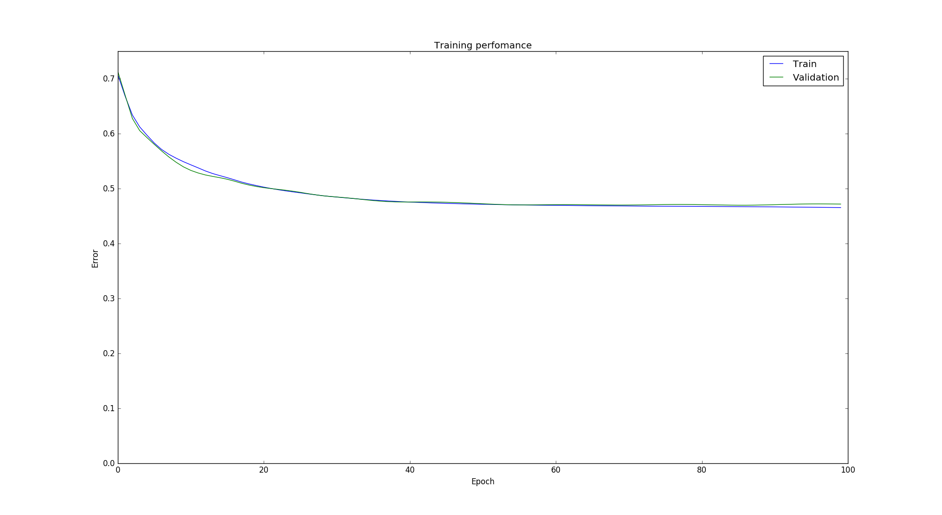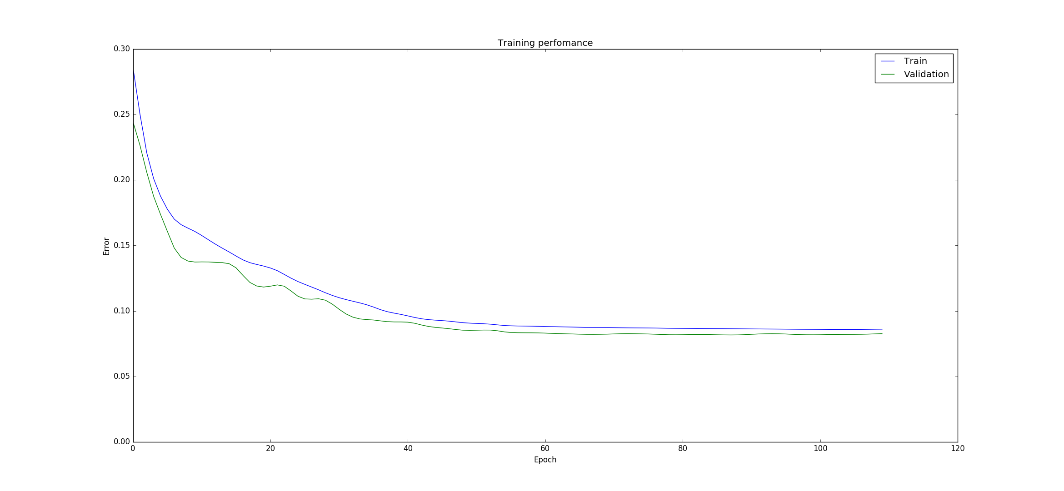

## Results and discussion

Note that the second period test data were never used during the model development so that these forecasting models were always tested on truly untouched out-of-sample data.

The predictive performances of the developed models

were evaluated using the untouched out-of-sample data

(second period). This is due to the fact that the superior insample

performance does not always guarantee the validity

of the forecasting accuracy. One possible approach for

evaluating the forecasting performance is to investigate

whether traditional error measures such as those based on

the RMSE or correlation (CORR) between the actual out-ofsample

returns and their predicted values are small or highly

correlate, respectively. However, there is some evidence in

the literature suggesting that traditional measures of

forecasting performance may not be strongly related to

profits from trading (Pesaran and Timmermann, 1995). An

alternative approach is to look at the proportion of time that

the signs of excess stock returns (SIGN) are correctly

predicted. In fact, Leitch and Tanner (1991) state that the

forecasting performance based on the sign measure matches

more closely to the profitability performance than do

traditional criteria.

Trading rules and accumulation index

Level estimation test results

|  |  |  |  |
| --- | --- | --- | --- |
| **Network** | **Returns Error RMSE (logDiff)** | **Classification Rate (%)** | **Strategy PNL (Index Value)** |
| MLP | 0.00771 | Guessed 1001 out of 1670 = 59% correct | 22440.326 |
| GRNN | 0.00786 | Guessed 1014 out of 1670 = 60% correct | 23203.006 |

[ALGORITHM] ConjugateGradient

[ARCHITECTURE] Tanh(10) > Tanh(29) > Output(1)

Network options

Verbose:

[OPTION] verbose = True

BaseNetwork:

[OPTION] epoch_end_signal = None

[OPTION] show_epoch = 10

[OPTION] shuffle_data = False

[OPTION] step = 0.1

[OPTION] train_end_signal = None

ConstructableNetwork:

[OPTION] error = rmse

GradientDescent:

[OPTION] addons = ['LinearSearch']

ConjugateGradient:

[OPTION] update_function = fletcher_reeves

LinearSearch:

[OPTION] maxiter = 10

[OPTION] search_method = golden

[OPTION] tol = 0.1

Test MLP Results - Intra Day Returns Performance

Mean err = -1.80020861245e-05

RMSE = 0.00770790148919

Test MLP Level Est - Classification Results

Feedforward_MLP_extLEVEL: Guessed 1001 out of 1670 = 59% correct

Feedforward_MLP_extLEVEL: Strategy PNL = 22440.326, Buy-Hold PNL = 10149.546903

GRNN:

[OPTION] std = 1.25

Test GRNN Results - Intra Day Returns Performance

Mean err = -0.000312658602318

RMSE = 0.00785841102131

Test GRNN Level Est - Classification Results

GRNN_Network: Guessed 1014 out of 1670 = 60% correct

GRNN_Network: Strategy PNL = 23203.006, Buy-Hold PNL = 10149.546903

Direction classification test results

|  |  |  |
| --- | --- | --- |
| **Network** | **Classification Rate (%)** | **Strategy PNL (Index Value)** |
| MLP | Guessed 1033 out of 1670 = 61% | 24193.394 |
| PNN | Guessed 1022 out of 1670 = 61% correct | 23626.884 |

[ALGORITHM] ConjugateGradient

[ARCHITECTURE] Tanh(11) > Tanh(27) > Output(1)

Network options

Verbose:

[OPTION] verbose = True

BaseNetwork:

[OPTION] epoch_end_signal = None

[OPTION] show_epoch = 5

[OPTION] shuffle_data = False

[OPTION] step = 0.1

[OPTION] train_end_signal = None

ConstructableNetwork:

[OPTION] error = rmse

GradientDescent:

[OPTION] addons = ['LinearSearch']

ConjugateGradient:

[OPTION] update_function = fletcher_reeves

LinearSearch:

[OPTION] maxiter = 10

[OPTION] search_method = golden

[OPTION] tol = 0.1

[THEANO] Initializing Theano variables and functions.

[THEANO] Initialization finished sucessfully. It took 0.47 seconds

[WARN] There is no data to plot

Test MLP Direction Est - Classification Results

Feedforward_MLP_extDIRECTION_SINGLE_VEC: Guessed 1033 out of 1670 = 61% correct

Feedforward_MLP_extDIRECTION_SINGLE_VEC: Strategy PNL = 24193.394, Buy-Hold PNL = 10149.546903

PNN Classification Results - Test Std dev input

[ALGORITHM] PNN

PNN:

[OPTION] std = 1.25

Test PNN Est - Classification Results

PNN_Network: Std dev 1.25: Guessed 1022 out of 1670 = 61% correct

PNN_Network: Strategy PNL = 23626.884, Buy-Hold PNL = 10149.546903

A trading simulation was developed to further compare our results to a typical buy-and-hold strategy.

We compared two hypothetical portfolios, one representing the ASX200 and another investing based on the buy/sell signals generated by our neural network.

Results look promising but further testing is required!

## Conclusion and future work

Results we obtained using RMSE and accuracy percentage were promising, and broadly inline with what was achieved in the paper.

There does appear to be inefficiencies in the market we can exploit.

The trading simulation showed better than expected results, and could be enhanced to account for dividends, taxes and transaction costs to produce a more realistic P&L.

Further work can be done to optimise the input selection and neural network parameters.

We can also look at applying more rigorous testing against different time frames and market conditions to ensure our results are consistent and not just a statistical anomaly.

# Appendix

## Predictor Correlation Heat map

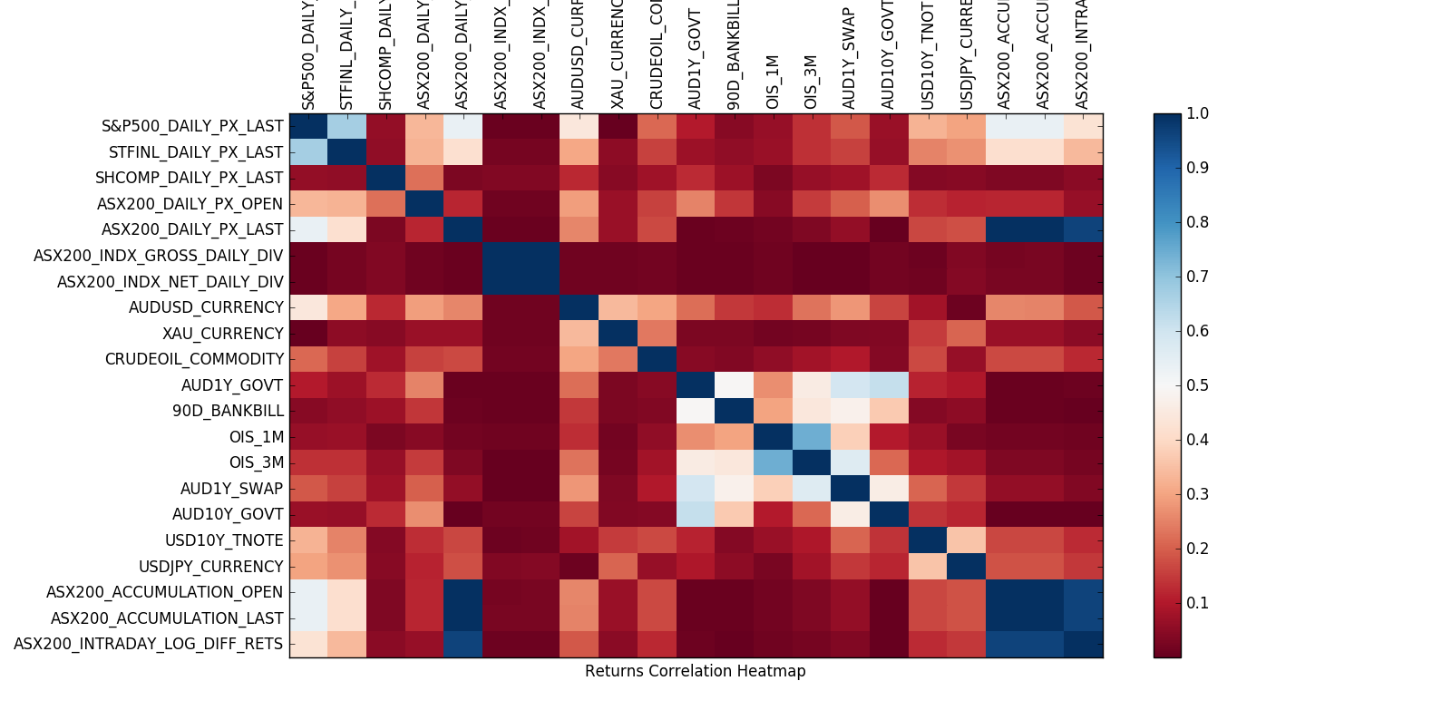

## OLS Regression

OLS Regression Results

===========================================================================

Dep. Variable: y R-squared: 0.219

Model: OLS Adj. R-squared: 0.214

Method: Least Squares F-statistic: 44.53

Date: Mon, 13 Jun 2016 Prob (F-statistic): 1.33e-108

Time: 19:50:40 Log-Likelihood: 2188.7

No. Observations: 2243 AIC: -4347.

Df Residuals: 2228 BIC: -4262.

Df Model: 14

Covariance Type: nonrobust

===========================================================================

coef std err t P>|t| [95.0% Conf.Int.]

---------------------------------------------------------------------------

const 0.1617 0.002 83.494 0.000 0.158 0.166

x1 0.0361 0.003 13.497 0.000 0.031 0.041

x2 0.0079 0.002 3.408 0.001 0.003 0.012

x3 -0.0072 0.002 -3.863 0.000 -0.011 -0.004

x4 0.0020 0.002 0.865 0.387 -0.003 0.007

x5 -0.0030 0.002 -1.291 0.197 -0.008 0.002

x6 0.0093 0.002 4.377 0.000 0.005 0.013

x7 -1.101e-05 0.002 -0.006 0.996 -0.004 0.004

x8 0.0004 0.002 0.173 0.863 -0.004 0.005

x9 0.0011 0.002 0.513 0.608 -0.003 0.005

x10 0.0030 0.002 1.478 0.140 -0.001 0.007

x11 0.0072 0.002 3.385 0.001 0.003 0.011

x12 -0.0034 0.003 -1.074 0.283 -0.010 0.003

x13 0.0023 0.003 0.856 0.392 -0.003 0.008

x14 -0.0011 0.003 -0.359 0.720 -0.007 0.005

===========================================================================

Omnibus: 318.010 Durbin-Watson: 2.291

Prob(Omnibus): 0.000 Jarque-Bera (JB): 4090.0

Skew: -0.142 Prob(JB): 0.00

Kurtosis: 9.609 Cond. No. 3.92

==========================================================================

## Prices Data

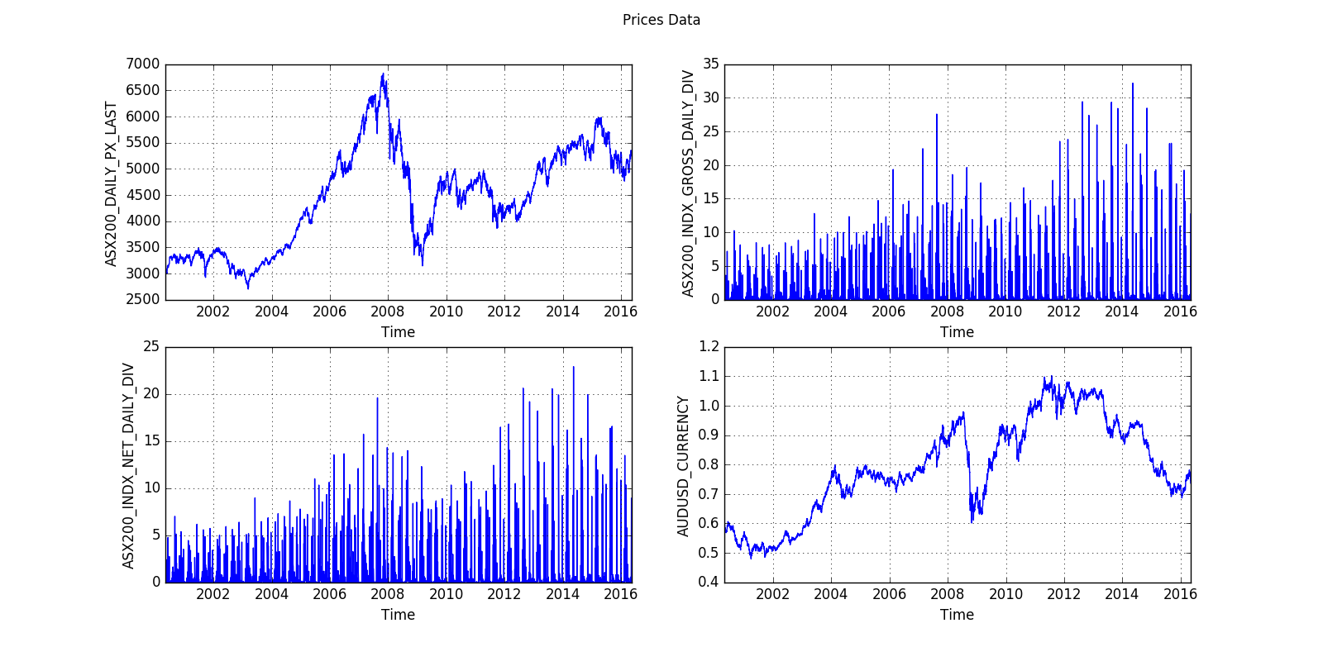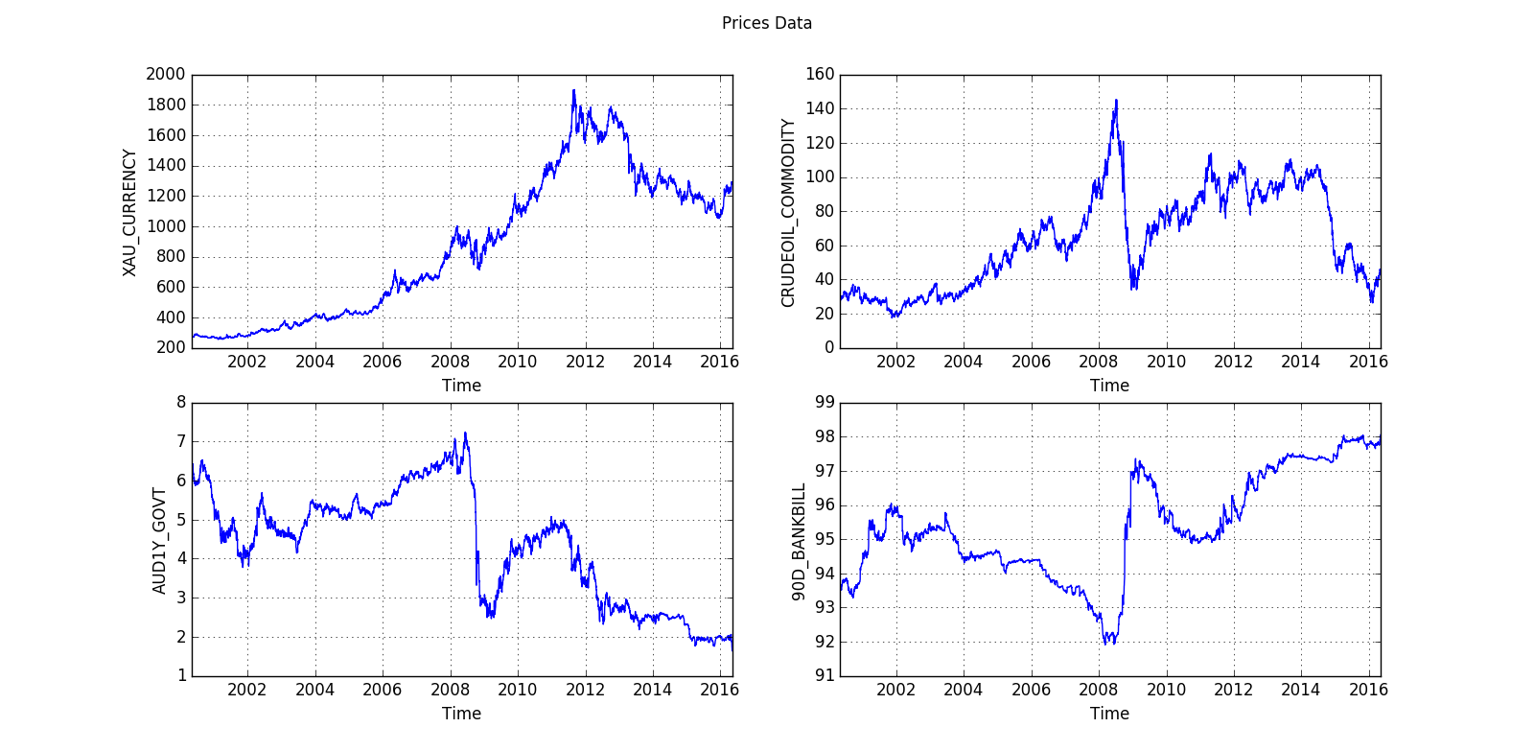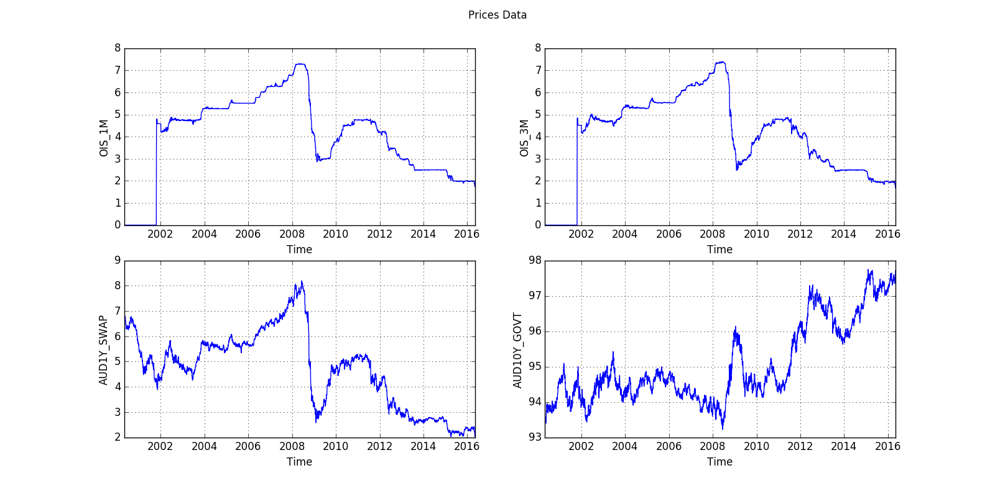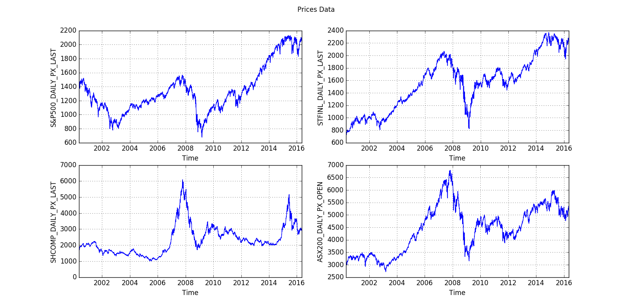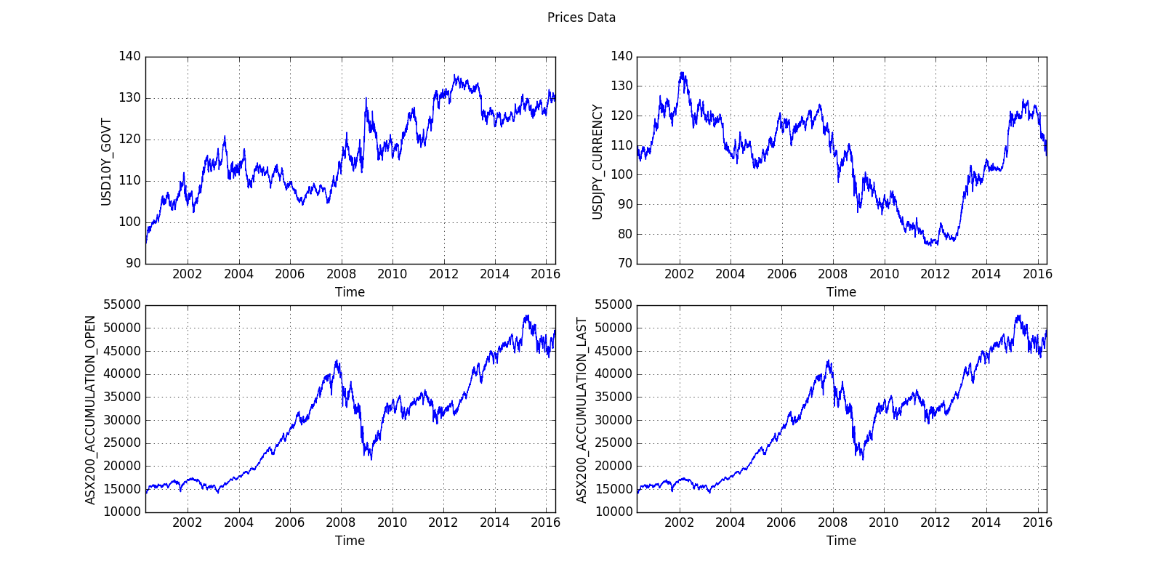

## Predictor Variables Standardised

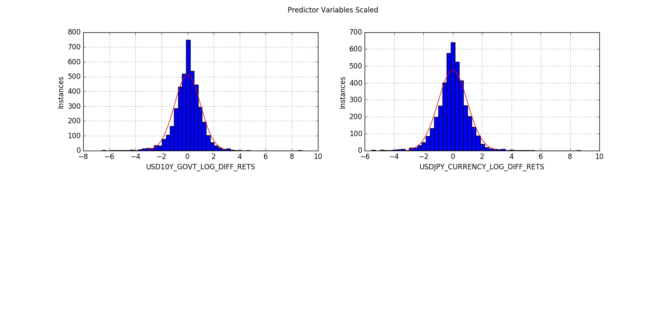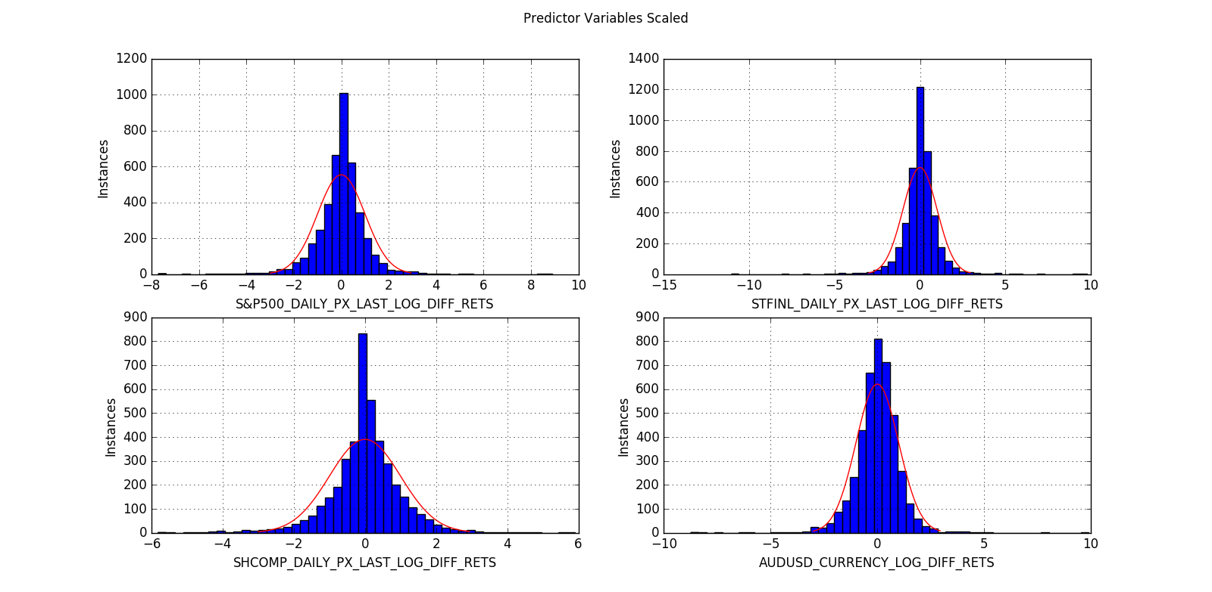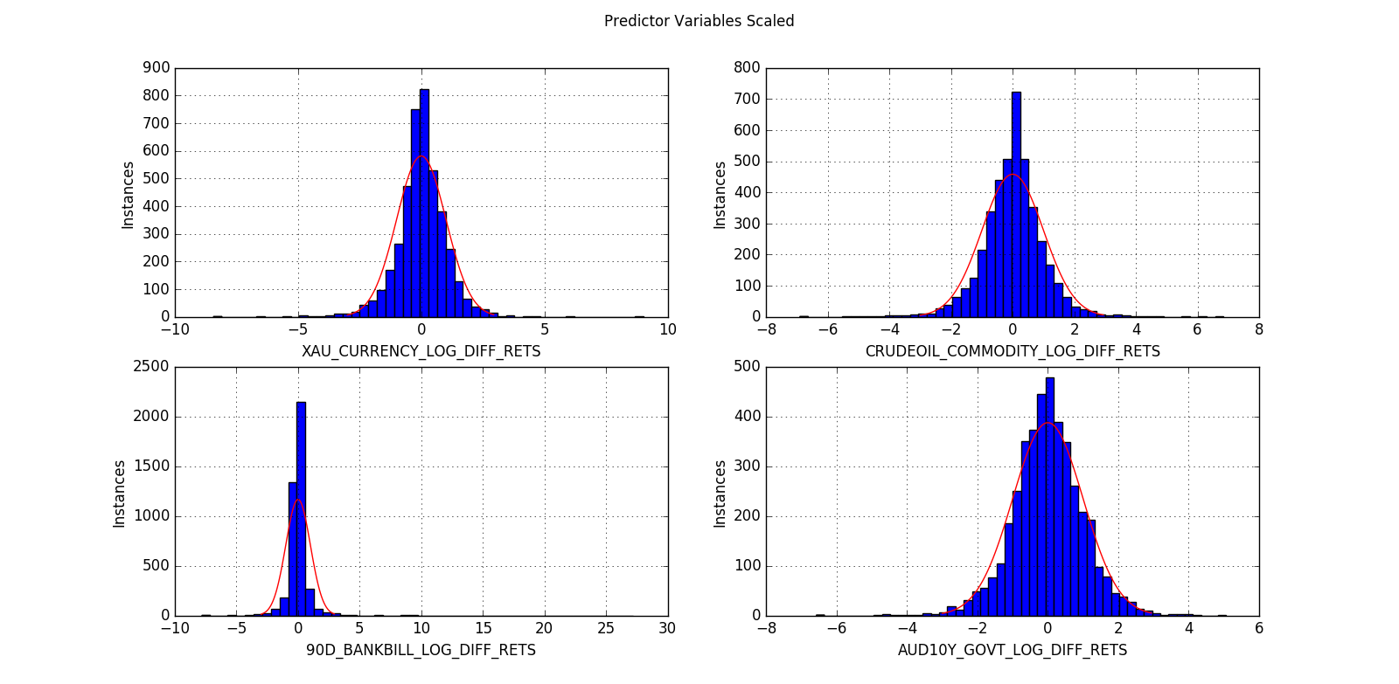

## Targets Scaled

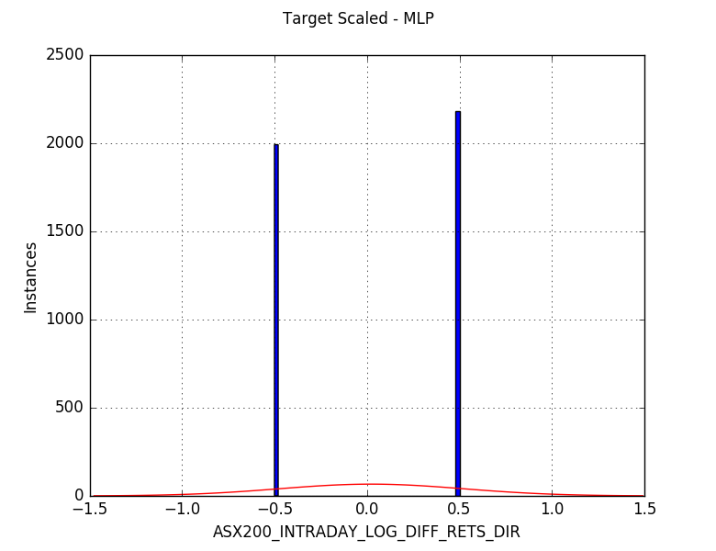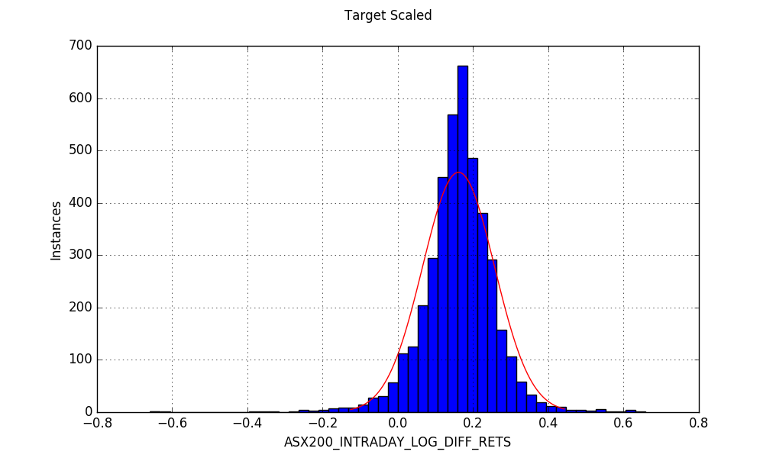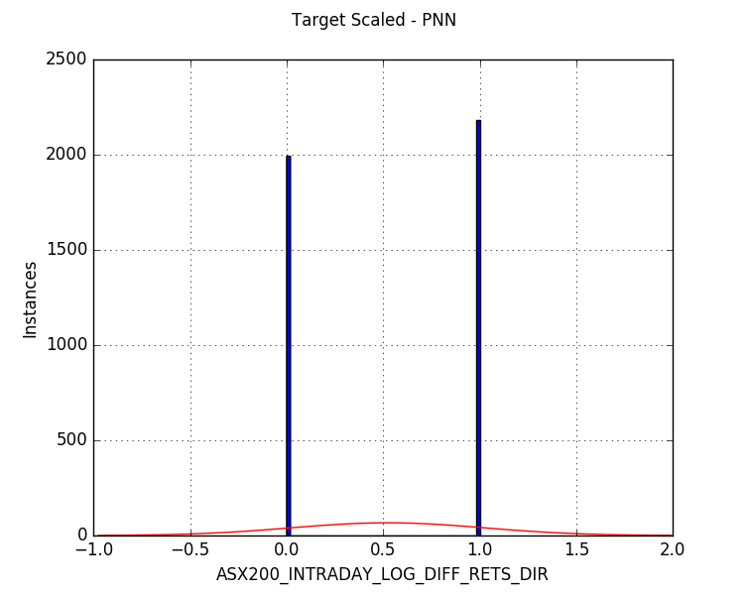

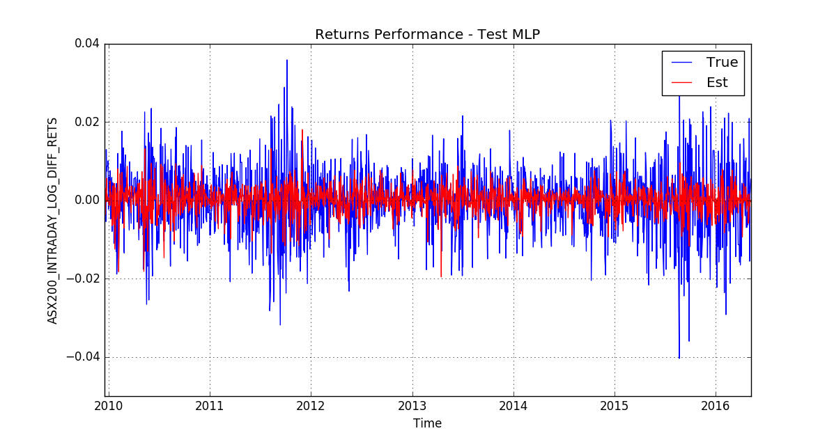 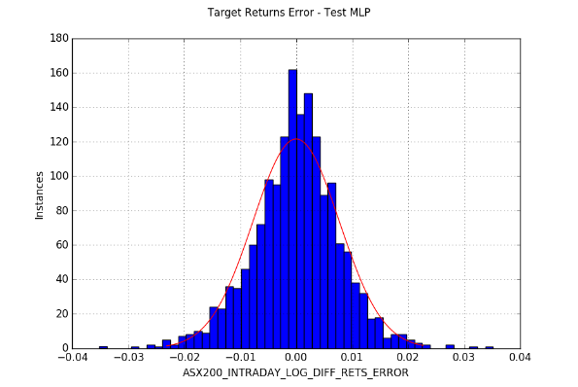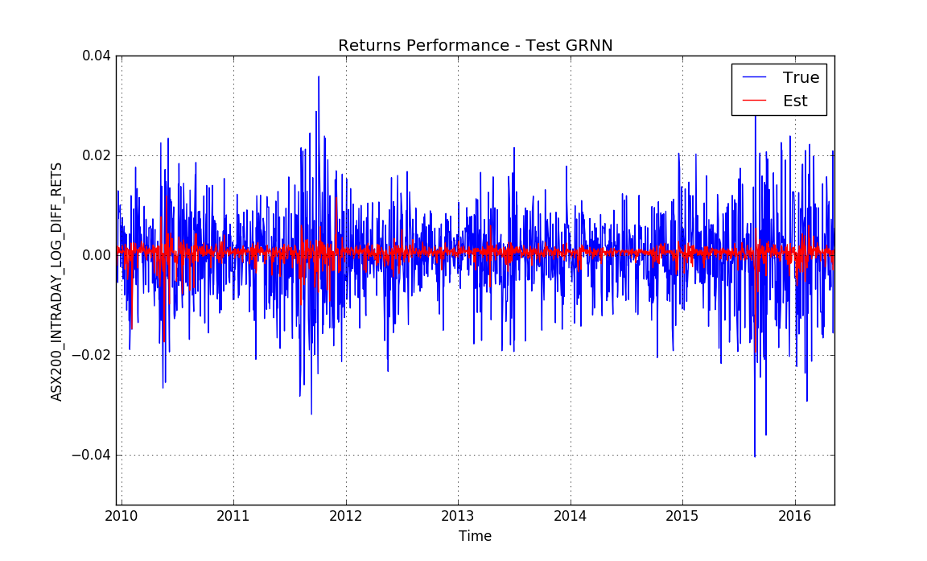 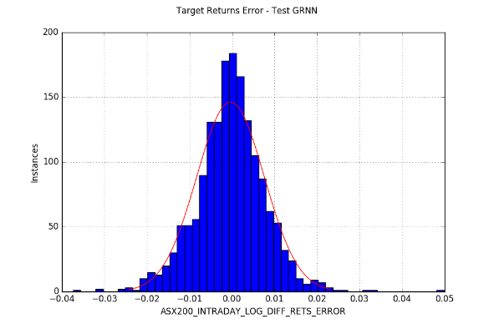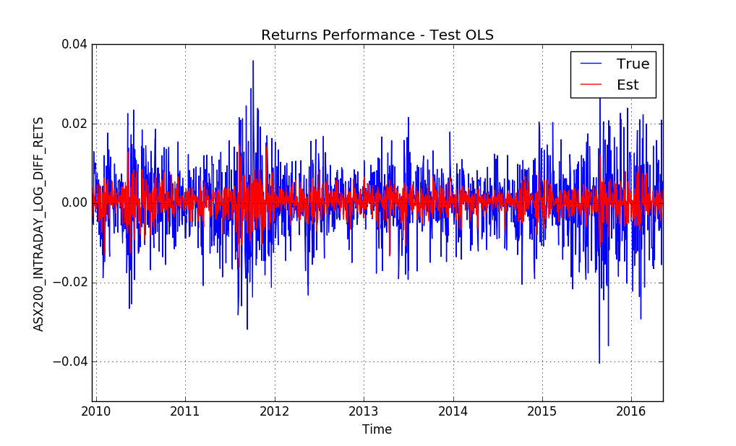 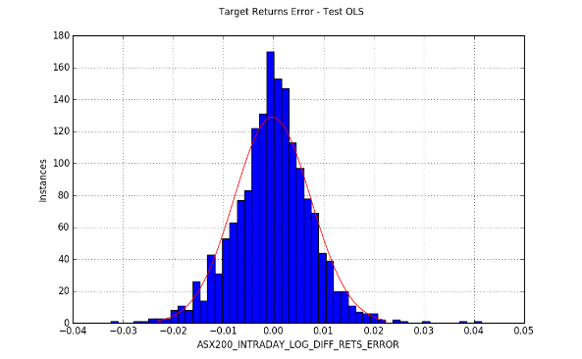

## Trading Simulation Results

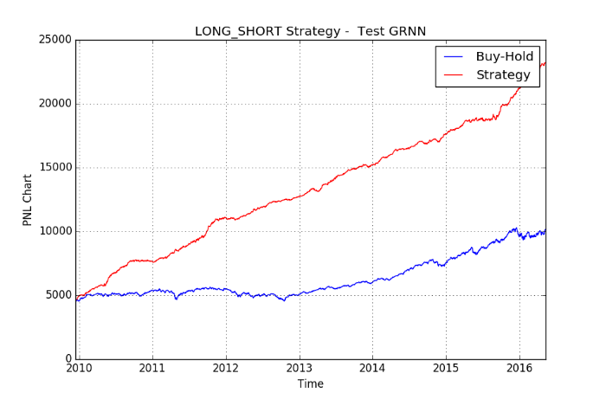

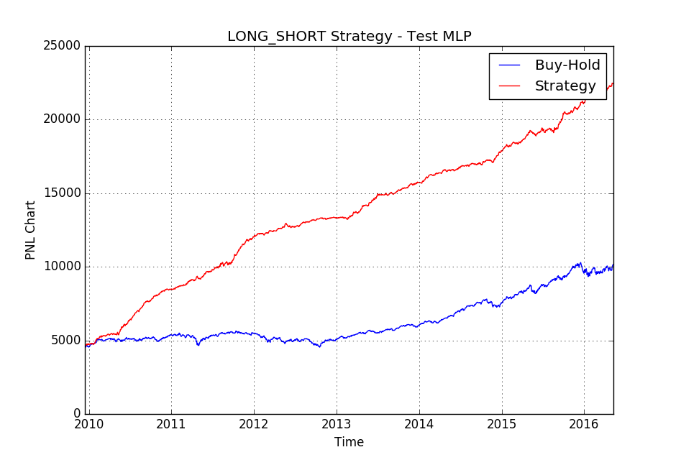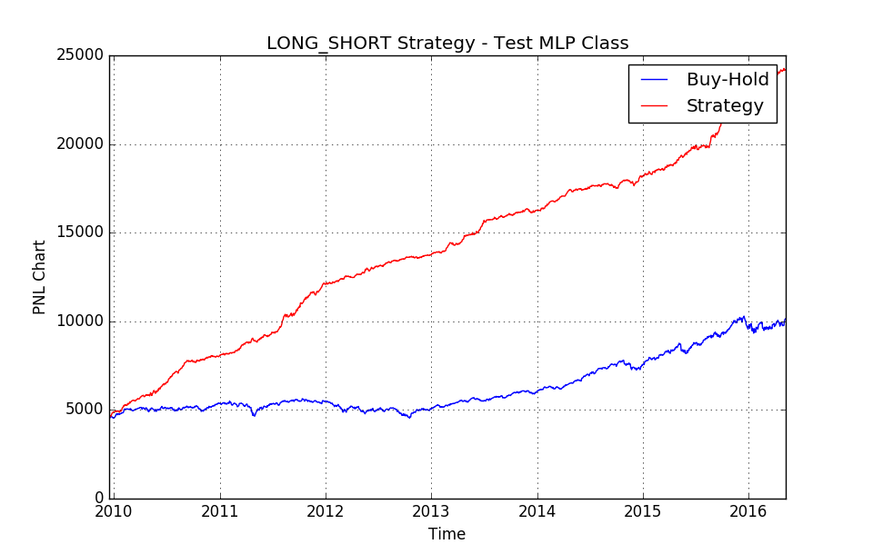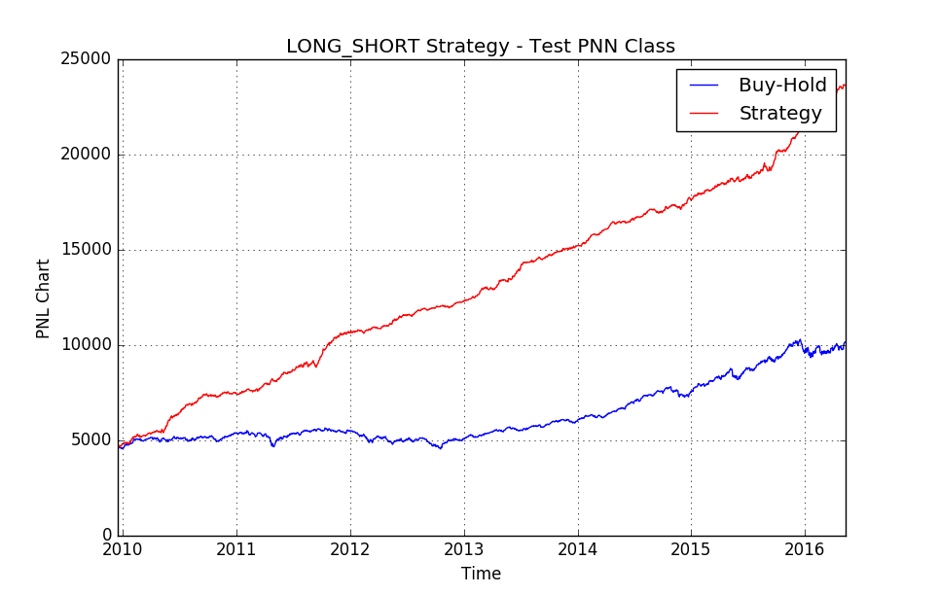

## Daily data summary

16 years of daily data was compiled from 9th May 2000 to 9th May 2016.

|  |  |  |  |  |
| --- | --- | --- | --- | --- |
| **Id.** | **Data label** | **Source** | **Lag (days)** | **Description** |
| *x1* | *'S&P500_DAILY_PX_LAST'* | Bloomberg | -1 | S&P500 Index close price |
| *x2* | *'STFINL_DAILY_PX_LAST'* | Bloomberg | -1 | Canadian Financials Index close price |
| *x3* | *'SHCOMP_DAILY_PX_LAST'* | Bloomberg | -1 | Shanghai Composite close price |
| *Y* | *'ASX200_DAILY_PX_OPEN'* | Bloomberg | 0 | ASX200 open price (not include dividends) |
| *Y* | *'ASX200_DAILY_PX_LAST'* | Bloomberg | 0 | ASX200 close price (not include dividends) |
| *X11* | *'ASX200_INDX_GROSS_DAILY_DIV'* | Bloomberg | 0 | Gross dividends ASX200 |
| *X4* | *'AUDUSD_CURRENCY'* | Bloomberg | -1 | AUD USD Exchange rate |
| *X5* | *'XAU_CURRENCY'* | Bloomberg | -1 | Gold price (commodity) |
| *X6* | *'CRUDEOIL_COMMODITY'* | Bloomberg | -1 | Crude oil price (commodity) |
| *X15* | *'AUD1Y_GOVT'* | Bloomberg | -1 | 1Y Australian Gov. Bond |
| *X7* | *'90D_BANKBILL'* | Bloomberg | -1 | 90 Day Bank Bill |
| *x12* | *'OIS_1M'* | Bloomberg | -1 | Overnight Index Swap Rate 1 Month Tenor |
| *x13* | *'OIS_3M'* | Bloomberg | -1 | Overnight Index Swap Rate 3 Month Tenor |
| *x14* | *'AUD1Y_SWAP'* | Bloomberg | -1 | Swap Rate 1 Y Maturity |
| *X8* | *'AUD10Y_GOVT'* | Bloomberg | -1 | 10Y Australian Gov. Bond |
| *X9* | *'USD10Y_GOVT'* | Bloomberg | -1 | 10Y American Gov. Bond |
| *x10* | *'USDJPY_CURRENCY'* | Bloomberg | -1 | USD Yen Exchange rate |
| *X16* | *'ASX200_ACCUMULATION_OPEN'* | Bloomberg | 0 | ASX200 Accumulation open price |
| *X17* | *'ASX200_ACCUMULATION_LAST'* | Bloomberg | 0 | ASX200 Accumulation close price |

## References

1. David Enke, Suraphan Thawornwong (2005), The use of data mining and neural networks for forecasting stock market returns; Expert Systems with Applications 29 (2005) 927–940
2. Mark T. Leunga, Hazem Daoukb, An-Sing Chenc (2000) Forecasting stock indices: a comparison of classification and level estimation models; http://papers.ssrn.com/sol3/papers.cfm?abstract_id=200429
3. Michal Tka, Robert Verner (2016) Artificial neural networks in business: Two decades of research; Applied Soft Computing 38 (2016) 788–804
4. Rodolfo C. Cavalcante, Rodrigo C. Brasileiro b , Victor L.F. Souza b , Jarley P. Nobrega, Adriano L.I. Oliveira (2016) Computational Intelligence and Financial Markets: A Survey and Future Directions; Expert Systems With Applications 55 (2016) 194–211
5. C. D. Tilakaratne, S. A. Morris, M. A. Mammadov, C. P. Hurst; Predicting Stock Market Index Trading Signals Using Neural Networks; Centre for Informatics and Applied Optimization School of Information Technology and Mathematical Sciences University of Ballarat, PO Box 663, Ballarat, Victoria, Australia

## Source Code

Python

List of predictor labels

1 S&P500_DAILY_PX_LAST_LOG_DIFF_RETS

2 STFINL_DAILY_PX_LAST_LOG_DIFF_RETS

3 SHCOMP_DAILY_PX_LAST_LOG_DIFF_RETS

4 ASX200_INDX_GROSS_DAILY_DIV

5 AUDUSD_CURRENCY_LOG_DIFF_RETS

6 XAU_CURRENCY_LOG_DIFF_RETS

7 CRUDEOIL_COMMODITY_LOG_DIFF_RETS

8 90D_BANKBILL_LOG_DIFF_RETS

9 AUD10Y_GOVT_LOG_DIFF_RETS

10 USD10Y_TNOTE_LOG_DIFF_RETS

11 USDJPY_CURRENCY_LOG_DIFF_RETS

12 OIS_3M_LOG_DIFF_RETS

13 OIS_1M_LOG_DIFF_RETS

14 AUD1Y_SWAP_LOG_DIFF_RETS

Predictor Inputs sorted by cross-validated performance (% accuracy)

Input 1: Score: 0.58 Name: S&P500_DAILY_PX_LAST_LOG_DIFF_RETS

Input 2: Score: 0.53 Name: STFINL_DAILY_PX_LAST_LOG_DIFF_RETS

Input 4: Score: 0.52 Name: ASX200_INDX_GROSS_DAILY_DIV

Input 14: Score: 0.51 Name: AUD1Y_SWAP_LOG_DIFF_RETS

Input 6: Score: 0.5 Name: XAU_CURRENCY_LOG_DIFF_RETS

Input 11: Score: 0.5 Name: USDJPY_CURRENCY_LOG_DIFF_RETS

Input 10: Score: 0.5 Name: USD10Y_TNOTE_LOG_DIFF_RETS

Input 3: Score: 0.5 Name: SHCOMP_DAILY_PX_LAST_LOG_DIFF_RETS

Input 7: Score: 0.5 Name: CRUDEOIL_COMMODITY_LOG_DIFF_RETS

Input 5: Score: 0.5 Name: AUDUSD_CURRENCY_LOG_DIFF_RETS

Input 12: Score: 0.49 Name: OIS_3M_LOG_DIFF_RETS

Input 8: Score: 0.49 Name: 90D_BANKBILL_LOG_DIFF_RETS

Input 9: Score: 0.48 Name: AUD10Y_GOVT_LOG_DIFF_RETS

Input 13: Score: 0.47 Name: OIS_1M_LOG_DIFF_RETS

Predictor Inputs sorted by cross-validated performance (R2 score)

Input 1: Score: 0.14 Name: S&P500_DAILY_PX_LAST_LOG_DIFF_RETS

Input 2: Score: 0.06 Name: STFINL_DAILY_PX_LAST_LOG_DIFF_RETS

Input 5: Score: -0.0 Name: AUDUSD_CURRENCY_LOG_DIFF_RETS

Input 6: Score: -0.01 Name: XAU_CURRENCY_LOG_DIFF_RETS

Input 3: Score: -0.01 Name: SHCOMP_DAILY_PX_LAST_LOG_DIFF_RETS

Input 12: Score: -0.01 Name: OIS_3M_LOG_DIFF_RETS

Input 13: Score: -0.01 Name: OIS_1M_LOG_DIFF_RETS

Input 14: Score: -0.01 Name: AUD1Y_SWAP_LOG_DIFF_RETS

Input 9: Score: -0.01 Name: AUD10Y_GOVT_LOG_DIFF_RETS

Input 8: Score: -0.01 Name: 90D_BANKBILL_LOG_DIFF_RETS

Input 11: Score: -0.02 Name: USDJPY_CURRENCY_LOG_DIFF_RETS

Input 7: Score: -0.02 Name: CRUDEOIL_COMMODITY_LOG_DIFF_RETS

Input 10: Score: -0.03 Name: USD10Y_TNOTE_LOG_DIFF_RETS

Input 4: Score: -0.03 Name: ASX200_INDX_GROSS_DAILY_DIV